# Sample Data:

Key Points

* Transaction Amount: 119
* Transactions Type: Mixed Account numbers, amount, details.
* Manually Inserted Anomalies: None

# Sample Data – 1:

Key Points

* Transaction Amount: 119
* Transactions Type: Same Account number, Same deposit and withdrawal amount, same details.
* Manually Inserted Anomalies: None

# Sample Data – 2:

Key Points

* Transaction Amount: 119
* Transactions Type: Same Account number, mostly same deposit and withdrawal amount, same details.
* Manually Inserted Anomalies: 2 fraud transaction inserted.

# Sample Data – 500:

Key Points

* Transaction Amount: 500
* Transactions Type: Mixed Account numbers, amount, details.
* Manually Inserted Anomalies: None

## **Results**

* Apply TDA Analysis

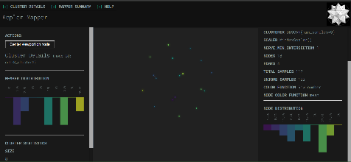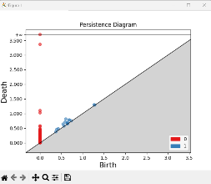 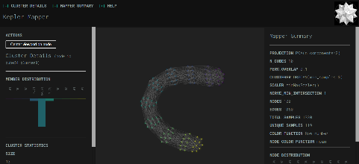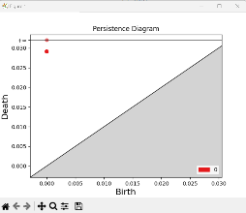

Sample Bank.csv

Sample Bank-1.csv

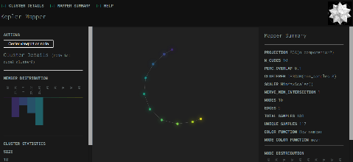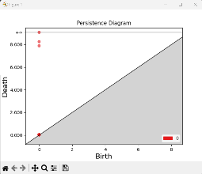 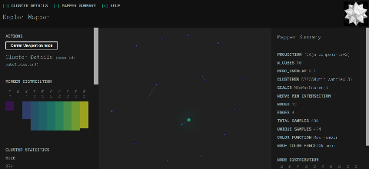

Sample Bank-2.csv

Sample Bank-500.csv

* Apply Machine Learning Analysis

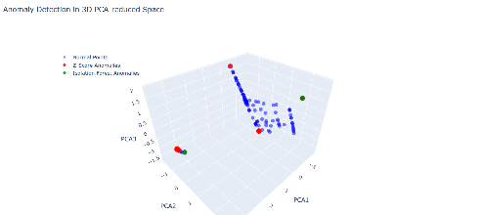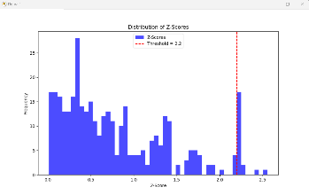 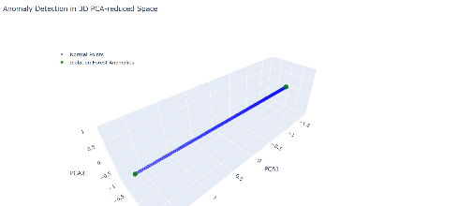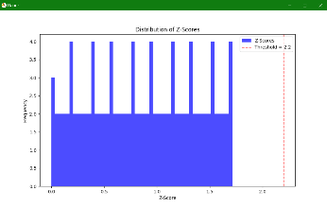

Sample Bank.csv

Sample Bank-1.csv

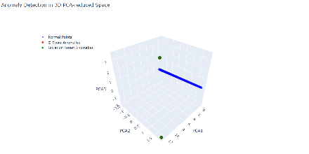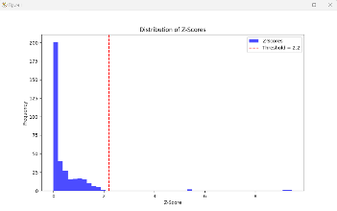 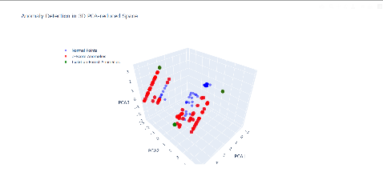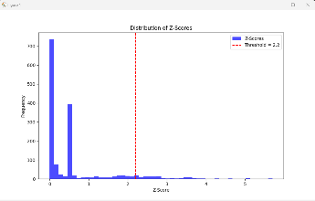

Sample Bank-500.csv

Sample Bank-2.csv

* Results

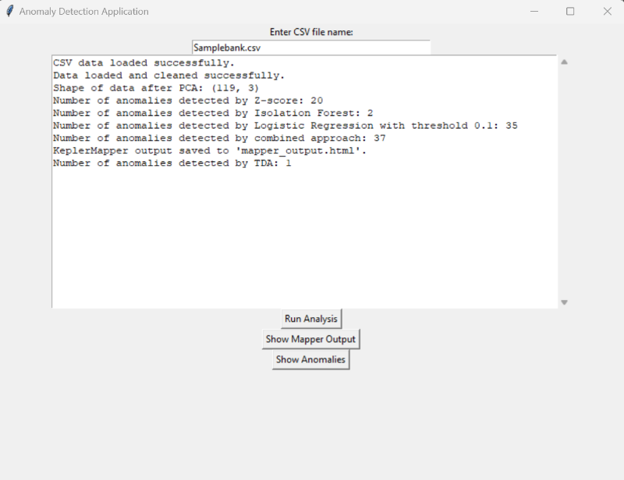 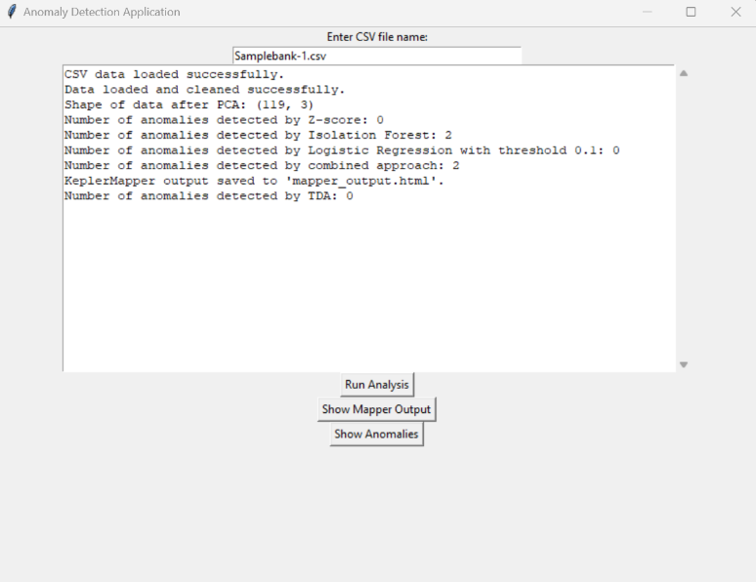

Sample Bank-1.csv

Sample Bank.csv

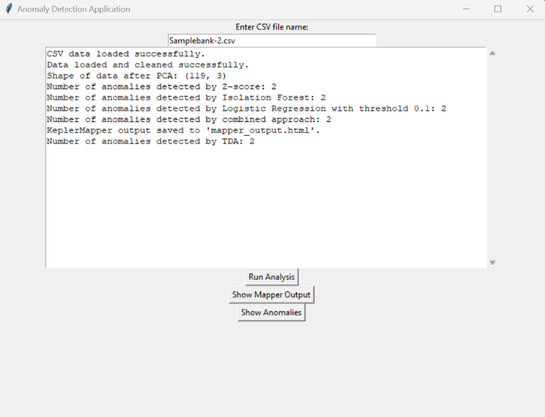 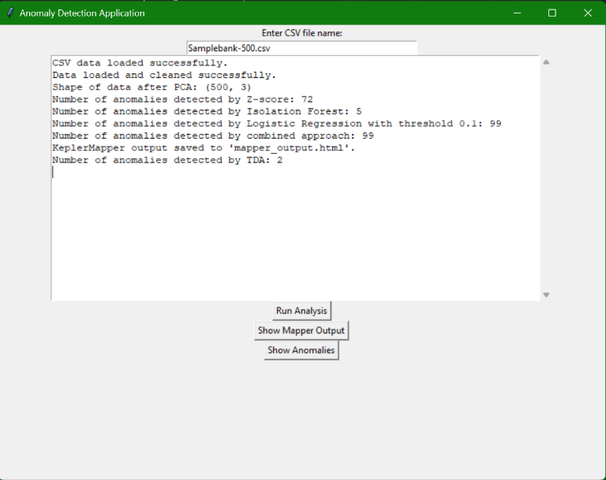

Sample Bank-500.csv

Sample Bank-2.csv